🛠️ The Tech Stack (The Toolkit)
To achieve "Workspaces" (e.g., Marvel vs. Family) and "Experiments," we need to upgrade our architecture slightly.
1. Frontend (The Experience)
- React + Vite: (You already have this).
- Framer Motion: Essential for the "Smooth animations" and "Moments of delight" you mentioned in the PDF.
- Recharts: To build graphs for the "Similarity Score" or "Accuracy Tests."
- React-Dropzone: For dragging and dropping multiple images.
- Zustand: For managing state (like "Current Workspace").
2. Middleware (The Manager - Node.js)
- Prisma: We need a real database now to track which user owns which workspace.
- Multer/FS: To manage file uploads into specific folders (e.g., uploads/user_1/workspace_marvel/).
3. The Brain (Python FastAPI)
- DeepFace: (Existing)
- OpenCV: For drawing the "Green Boxes" in the "Find Me" experiment.
- Pandas: To manage data analysis if users want to export results.

📅 The Master Work Plan
We will break this into 4 Phases. Do not try to do everything at once.
Phase 1: The "Workspace" Architecture (Backend Upgrade)
Currently, your system has one global database (known_faces). We need to make it dynamic so users can switch between "Game of Thrones" and "Marvel."
- Step 1.1: Update Prisma Schema to support Workspace and FaceCharacter.
- Step 1.2: Update Python API to accept a workspace_id.
  - Old: verify(image) -> loads global.pkl
  - New: verify(image, workspace_id) -> loads storage/{workspace_id}/embeddings.pkl
- Step 1.3: Create APIs to Create/Delete/Switch Workspaces.
Phase 2: Experiment 1 & 2 (The Analytics)
This focuses on the "Magic Mirror" and "Twin-O-Meter."
- Step 2.1: "Magic Mirror": Create a Python endpoint that runs DeepFace.analyze() (Age, Gender, Emotion) and returns JSON.
- Step 2.2: Frontend UI: Build a nice card component that flips over to reveal the analysis.
- Step 2.3: "Twin-O-Meter": Create a Python endpoint that compares two uploaded images and returns the distance float (0.0 to 1.0).
- Step 2.4: Frontend UI: Build a "Gauge" or "Progress Bar" that visualizes that number.
Phase 3: Experiment 3 (Computer Vision)
This is the "Find Me in the Crowd" feature.
- Step 3.1: Python Logic: Write a script that detects all faces in a group photo.
- Step 3.2: The Loop: Compare the "Target Face" against every face found in the group.
- Step 3.3: Drawing: Use OpenCV to draw a Green Rectangle on the match and Red Rectangles on non-matches.
- Step 3.4: Response: Return the processed image to the frontend.
Phase 4: Polish & "Moments of Delight"
This is where we implement the UI tips from your PDF.
- Step 4.1: Add Micro-interactions (e.g., Confetti when a face is added).
- Step 4.2: Add "Loading States" (e.g., "Scanning neural pathways..." instead of just "Loading").
- Step 4.3: Build the "History" tab (Prisma logs) so users can see past experiments.

🧠 Conceptual Change: How "Workspaces" will work
This is the hardest part to visualize, so here is the logic for your backend.
File Structure on your Server:
Instead of one folder, you will have this:
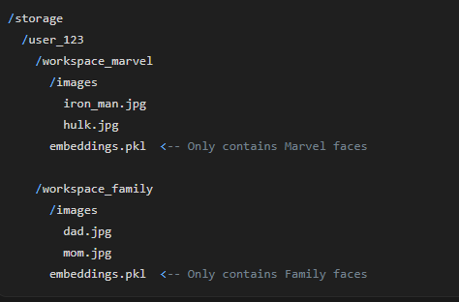

The Python Logic:
When the React App sends a request, it must send the workspace_id.
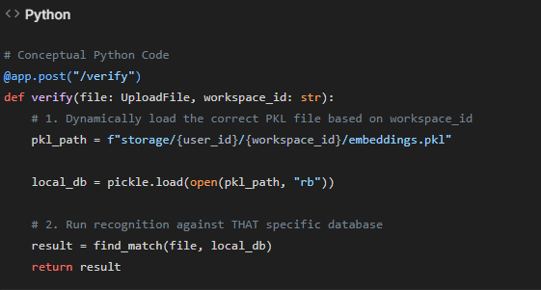

🚀 Immediate Next Step
We cannot build the UI until the Backend supports multiple workspaces.
Do you want to start with Phase 1 (Building the Multi-Workspace Backend System) today?
I can help you design the Prisma Schema and the Folder Logic first.

